**Boulder Climbing System**

**User Manual**

**By Team 15:**

Denis Stepanov, 20027064

Masrur Sobirov, 16519829

Yiming Chen, 16522026

Mingda Liu, 16522047

Tianhao Li, 16522042

Cheong Nam Kwong Melanie Mee-Lin, 20027069

**Installation**



Figure 1: QR Code for Download

Scan the QR code or access http://45.32.90.197/res/apk/BCS.apk to download the android package and install it on an Android mobile device.

**Installation**

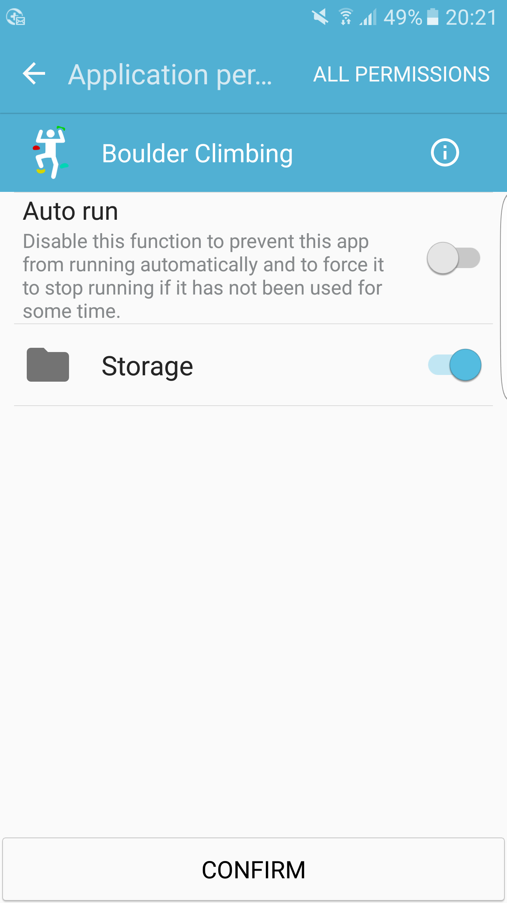

Figure 2: Grant permission

Install the android package and give it permission to use the storage. If application is not allowed to use the storage, it will load the pictures from the server every time when going over the pages in the application.

**Home Page**

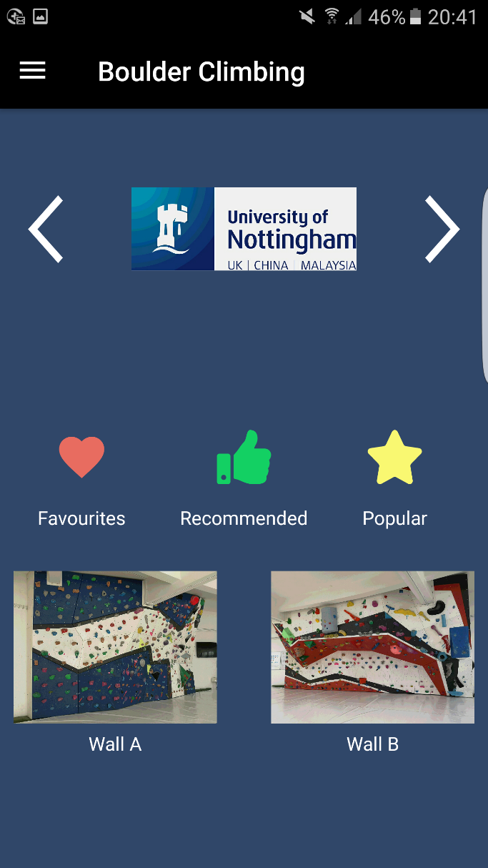

Figure 3: Overview of Home Page

Figure 3 displays the home page which shows Favourite, Recommended and Popular routes at the center. Furthermore, the navigation drawer button on top left corner, slides below the header, two buttons of main walls on the bottom. University of Nottingham’s logo can be pressed to jump to the school’s web-page.

**Home Page**

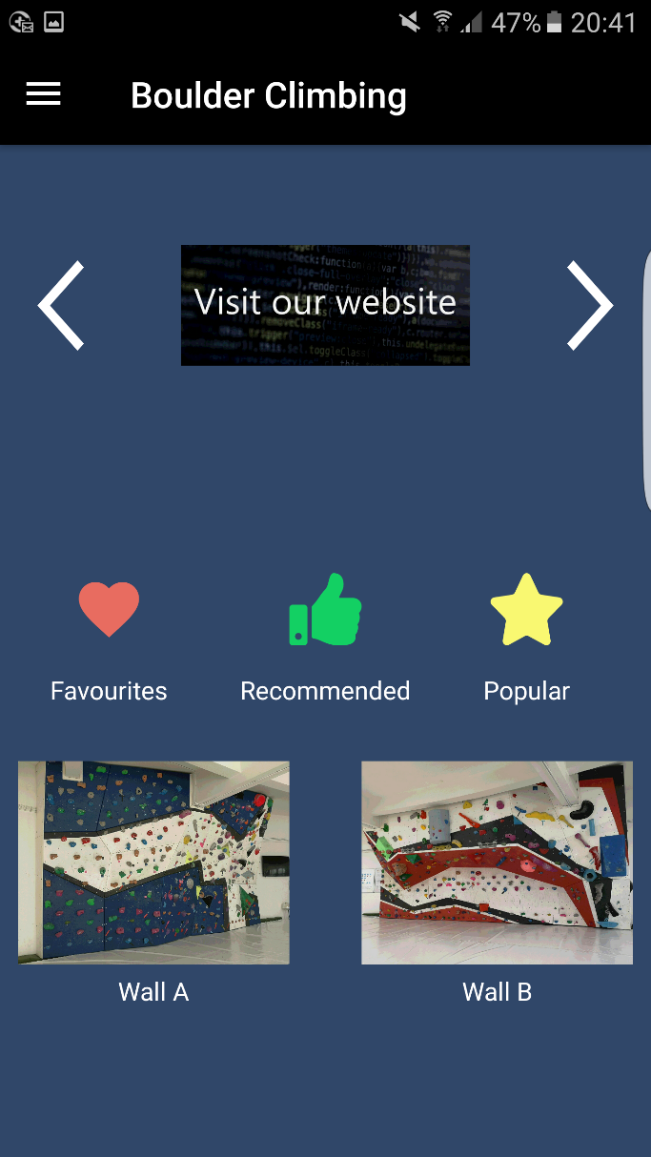

Figure 4: Slides

Press the slide with text “Visit our website” to jump to the website of our team’s project.

**Home Page**

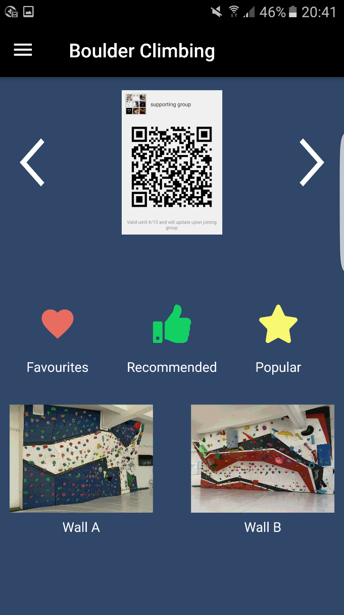

Figure 5: Slides

Slide shown on Figure 5 contains a QR code with link to team’s support chat. Scan it to get help or share the suggestions in the chat.

**“Hamburger” Menu**

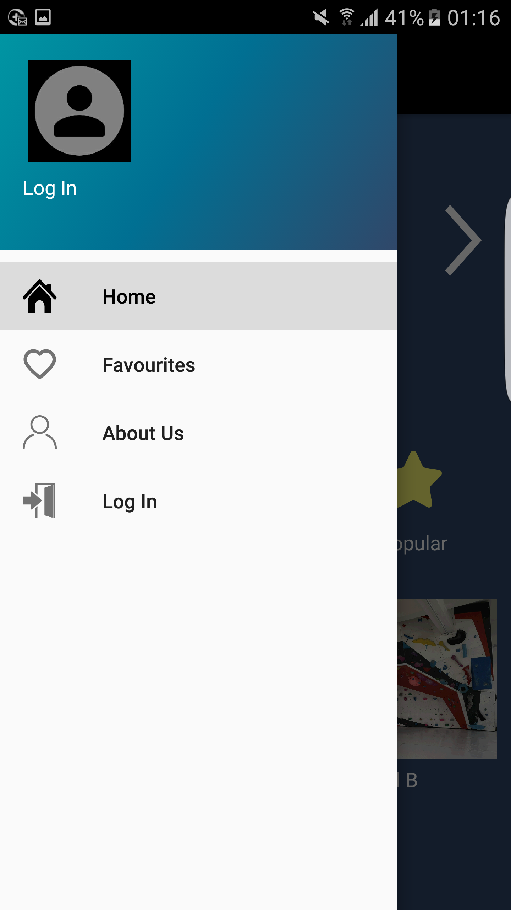

Figure 6: Navigation drawer

There are two parts in the menu shown in Figure 6. Upper part contains login information, which includes avatar, username and email. If not logged in: default avatar and “Log In” text. Lower part contains four buttons with different functions which are explained further.

**About Us**

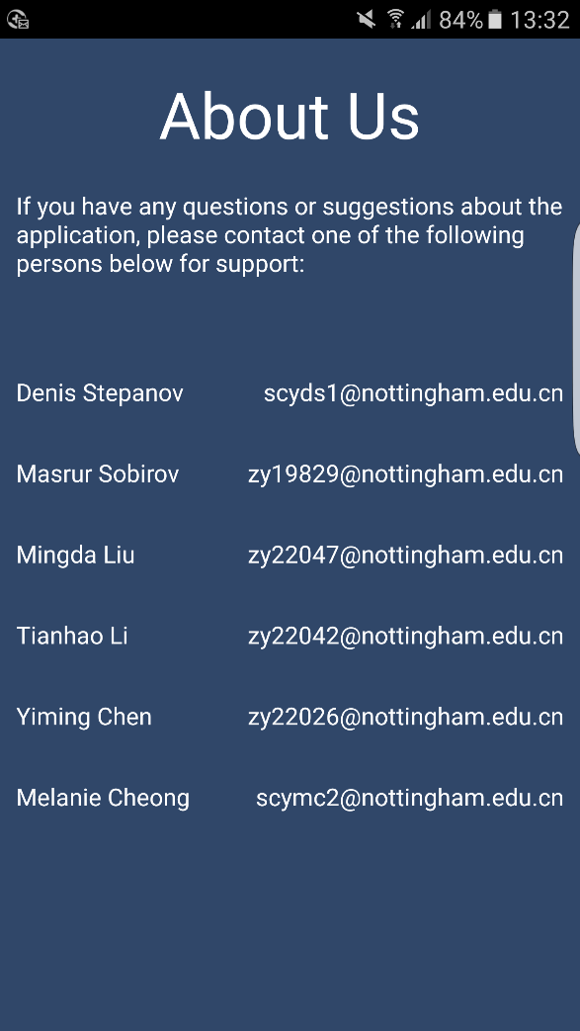



Figure 7: Hamburger – About Us

Press on “About Us” button to see a page with the team’s information.

**Log In**

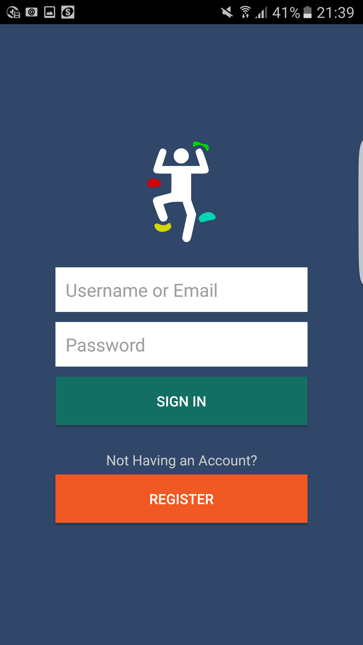

Figure 8: Hamburger – Log In

Press on the default avatar or the “Log In” button to go to the Log In page if not logged in.

**Log In**



Figure 9: Log In

Log in using the existing account’s username or email and password. To create an account press “Register” which will show Registration page.

**Log In**

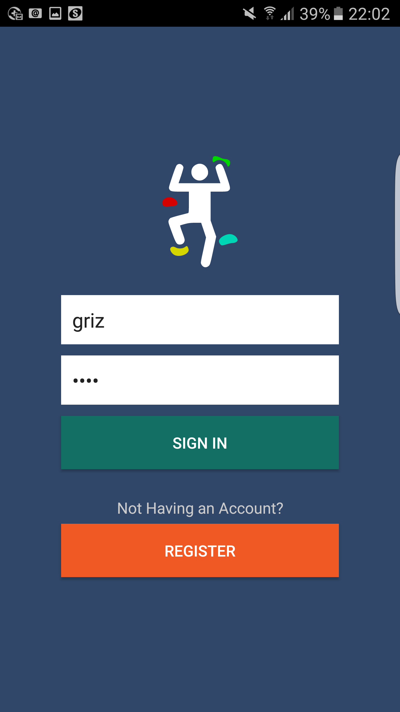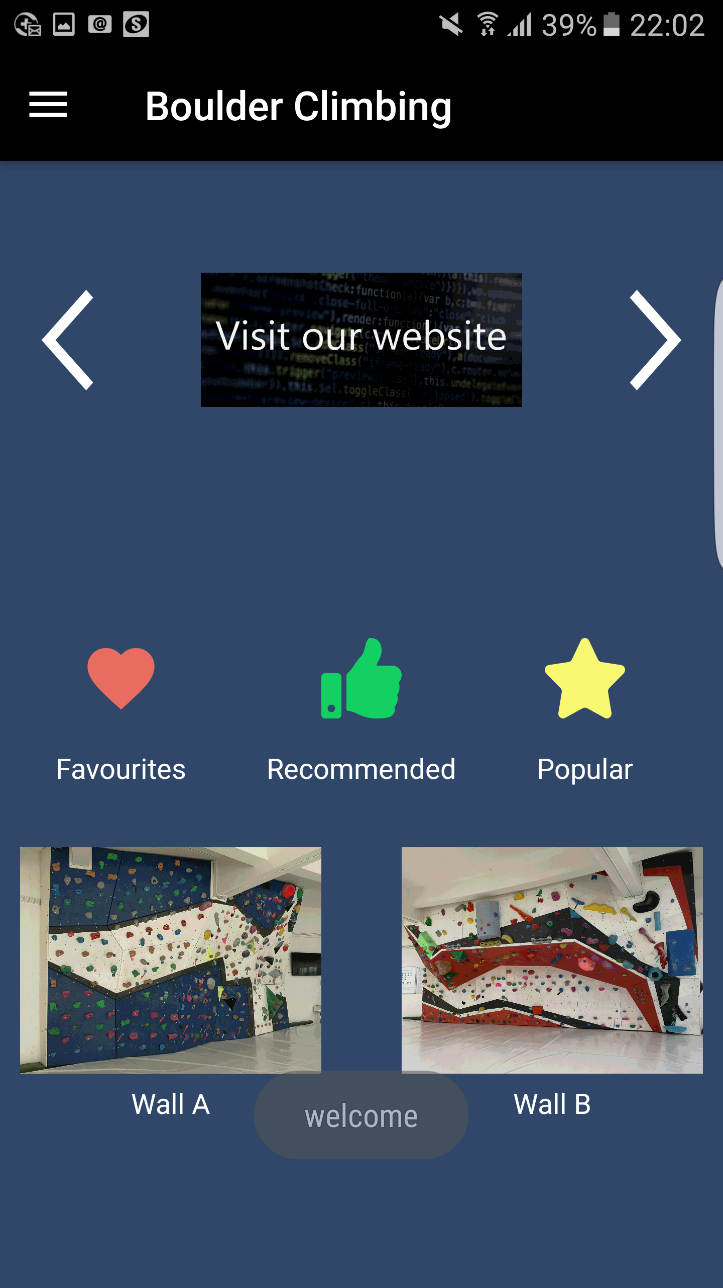

Figure 10: Log In – Home

Pressing on “SIGN IN” button, application displays the home page if login is valid.

**Registration**

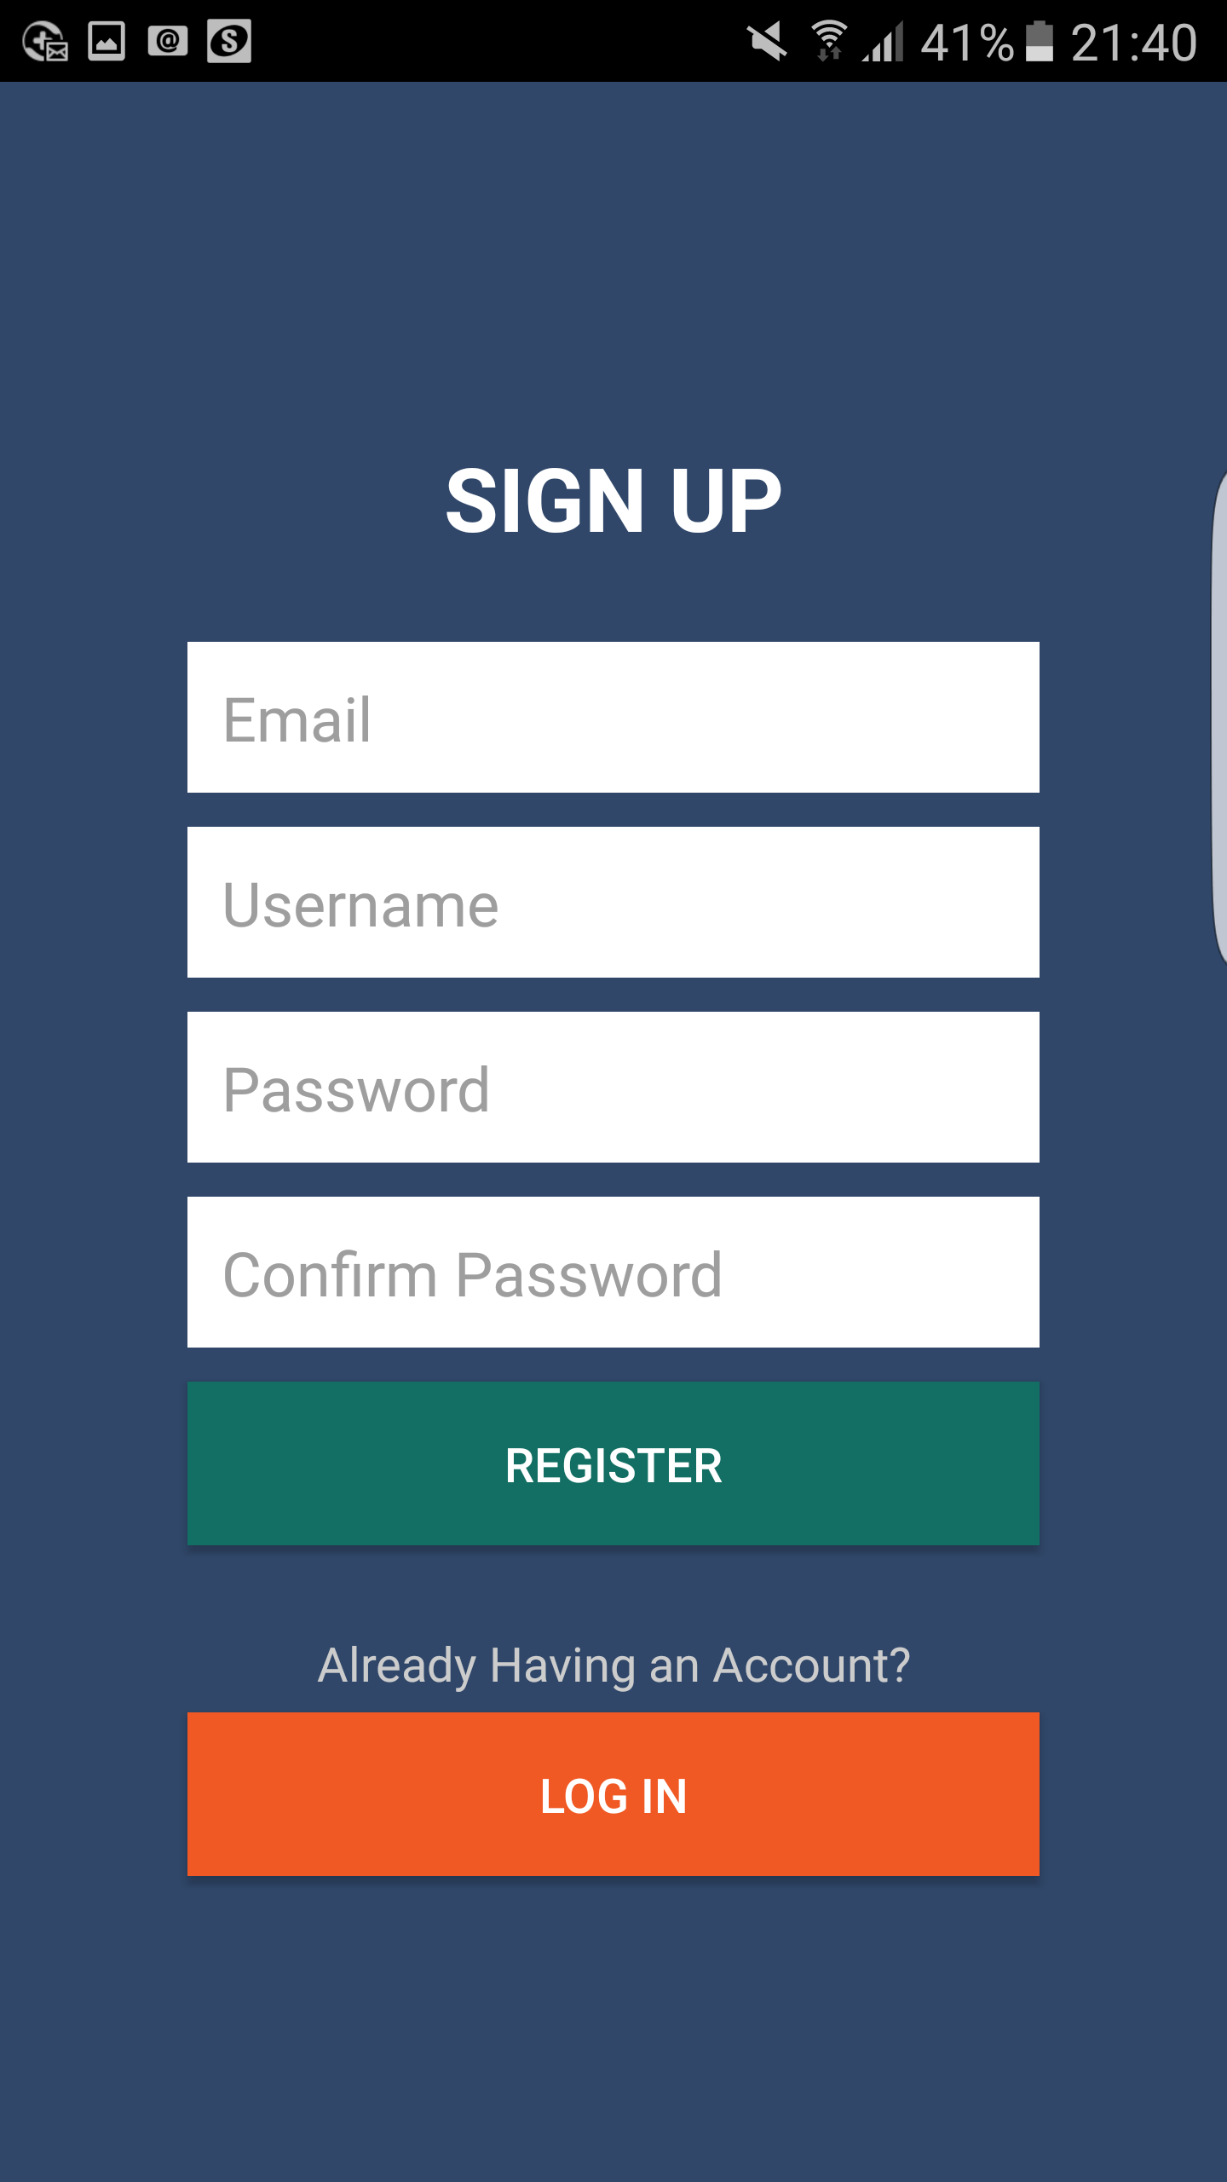

Figure 11: Registration

Register to access more functions of this application.

**Registration**

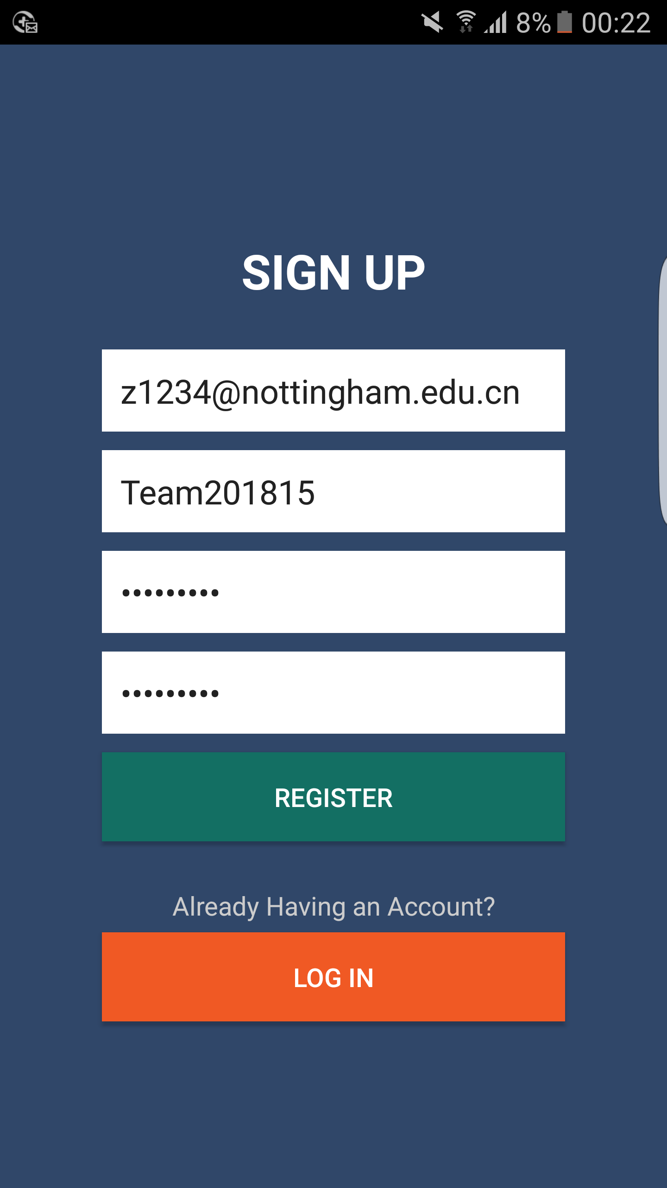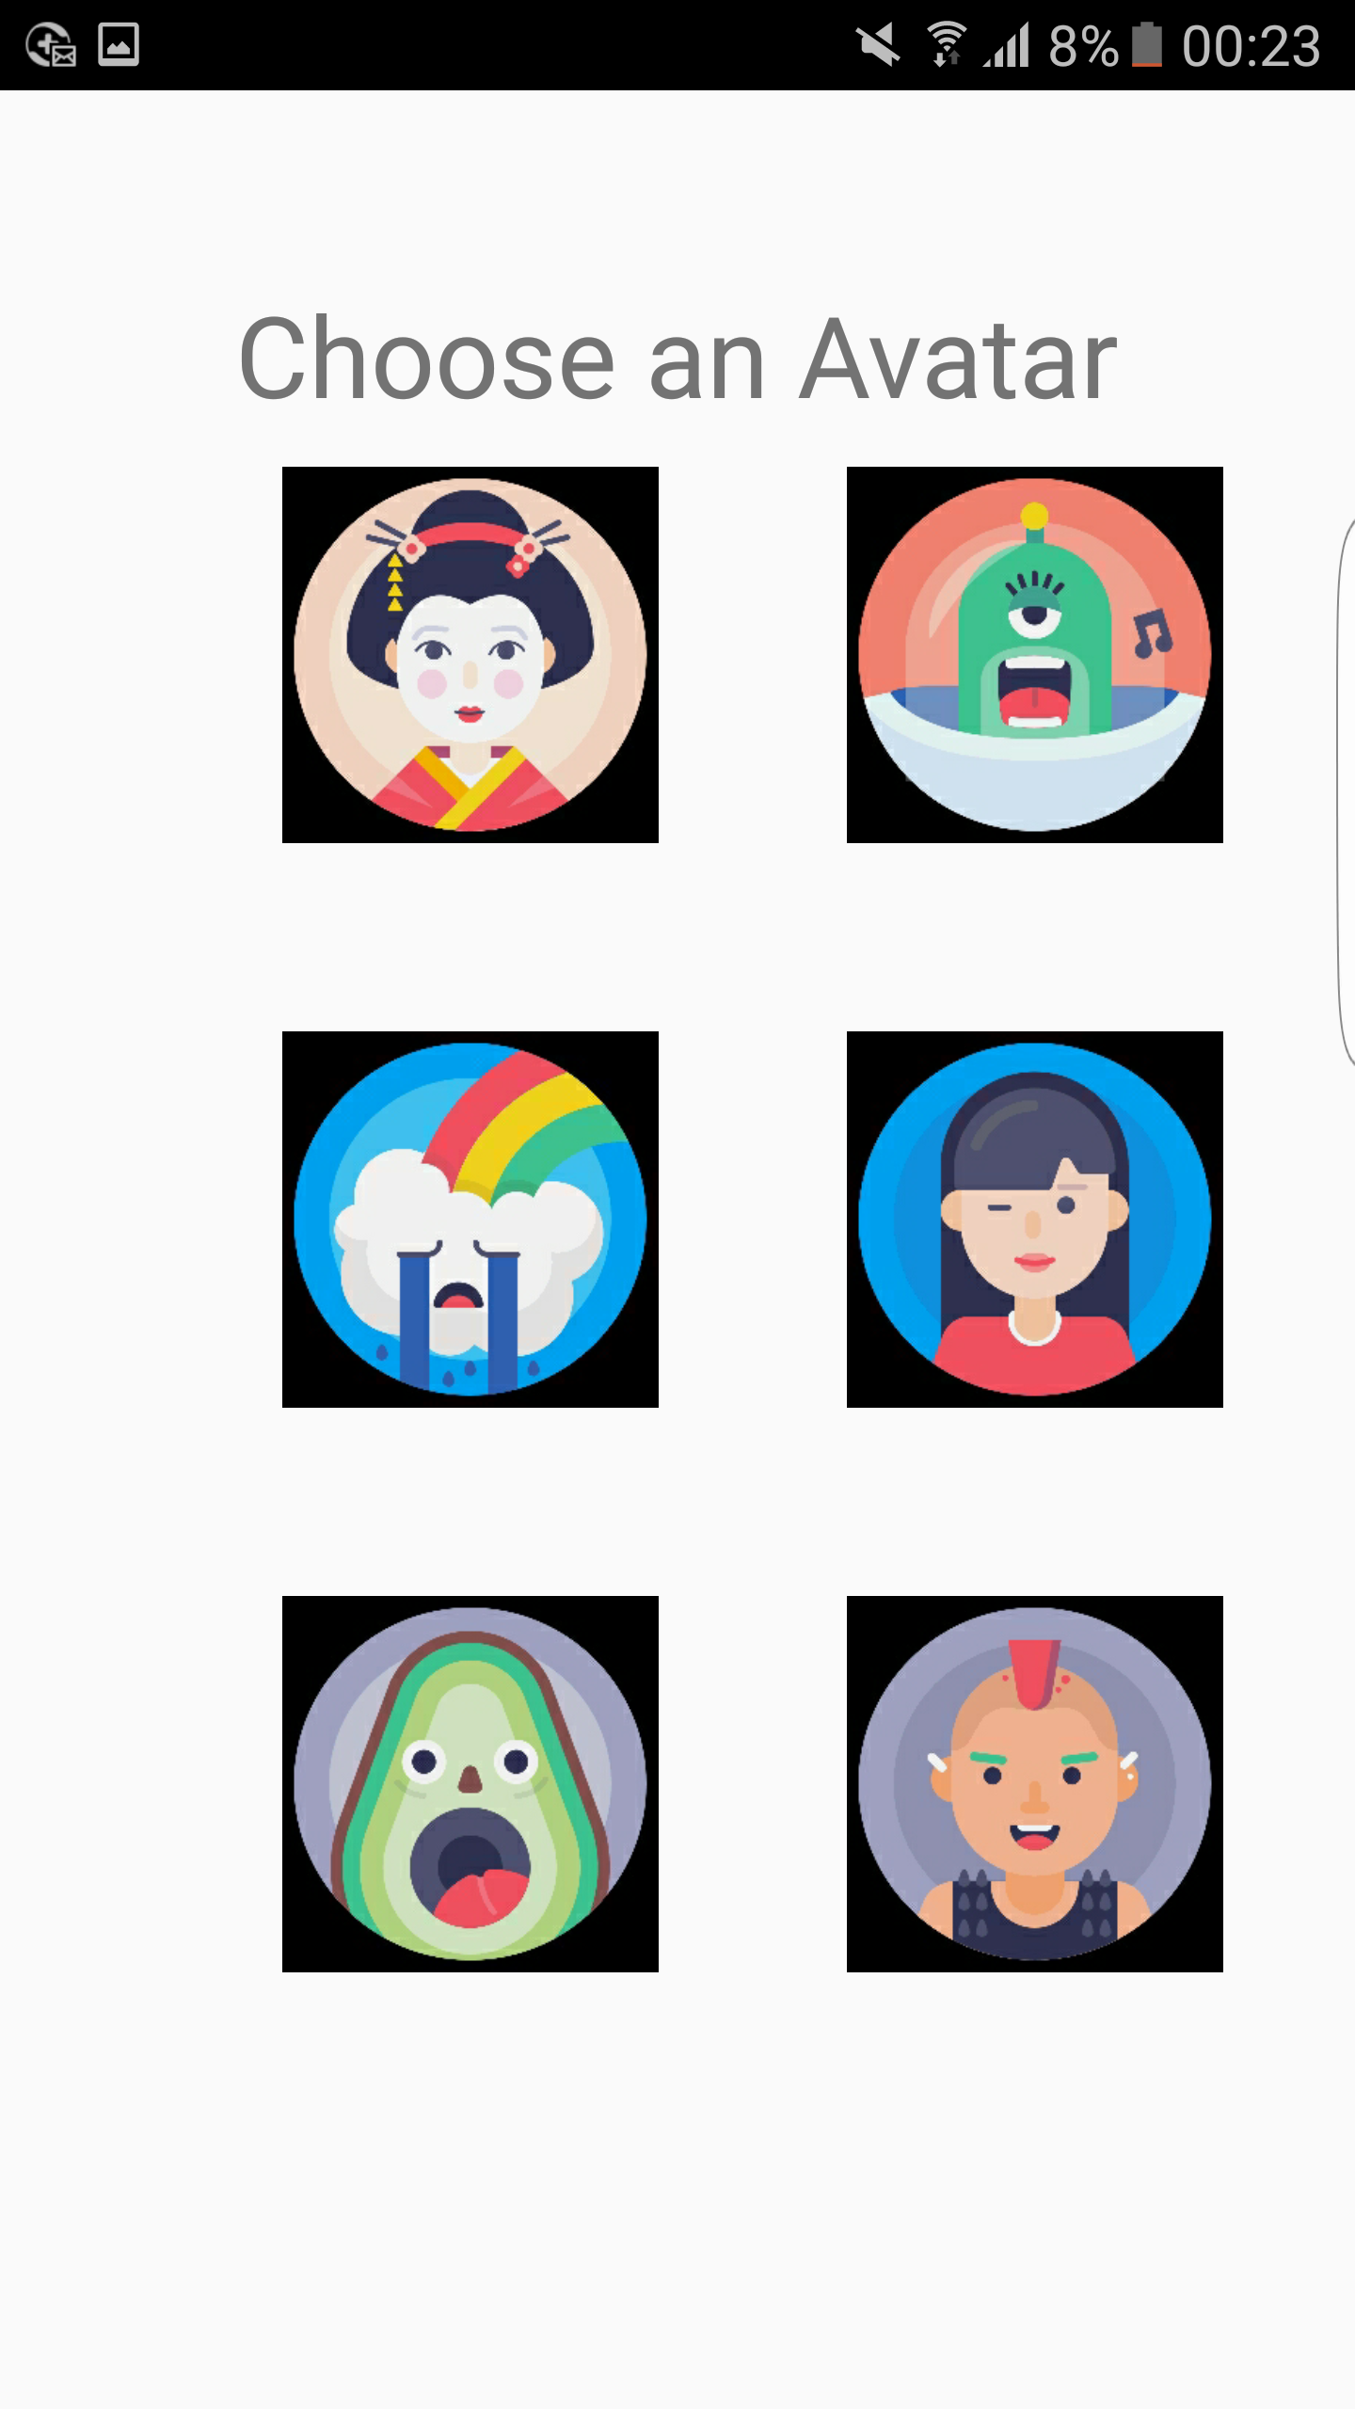

Figure 12: Register – Choose Avatar

When registration’s input is valid, press on “REGISTER” to choose avatar for the account.

Valid email address: common email address format.

Valid name: consists of letters or numbers with the length between 6 and 20.

Valid password: at least 6 characters length, must have letters and numbers.

Home page is displayed after registration.

If no avatar chosen, the avatar will be set the first by default

**Log In and Registration**



Figure 13: Log In - Registration

Switch between Log In and Registration pages by pressing the corresponding buttons.

**Hamburger**

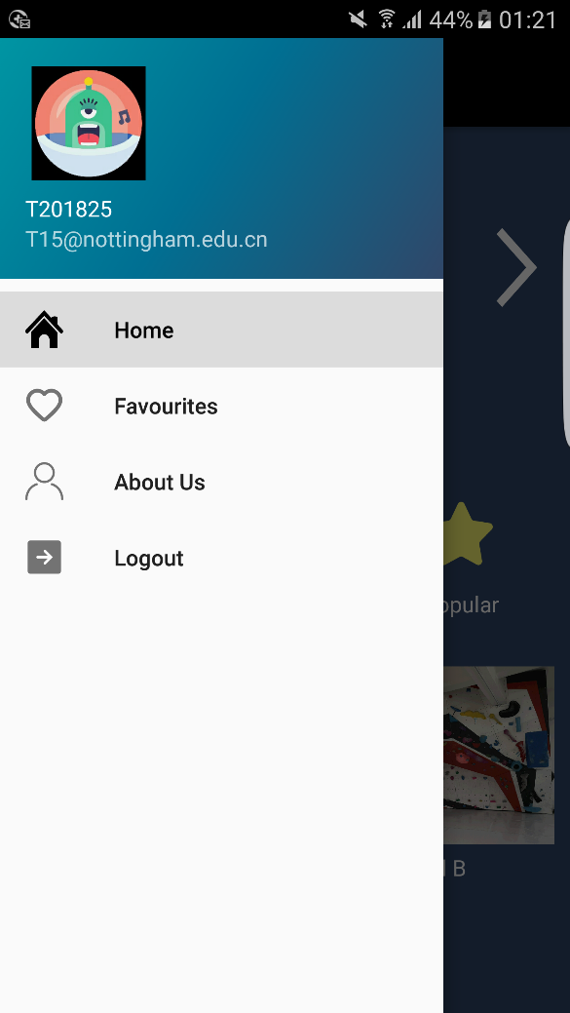 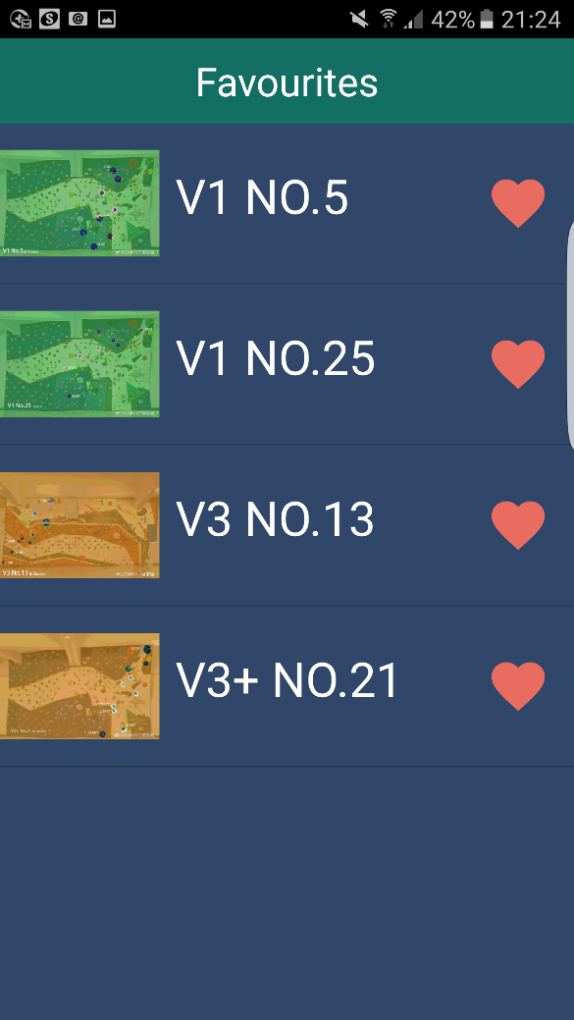

Figure 14: Favourites

If you are logged in, you can jump to favourite routes list by pressing on the “Favourites” button. Otherwise, a prompt window will pop up to remind you to log in.

**Hamburger**

 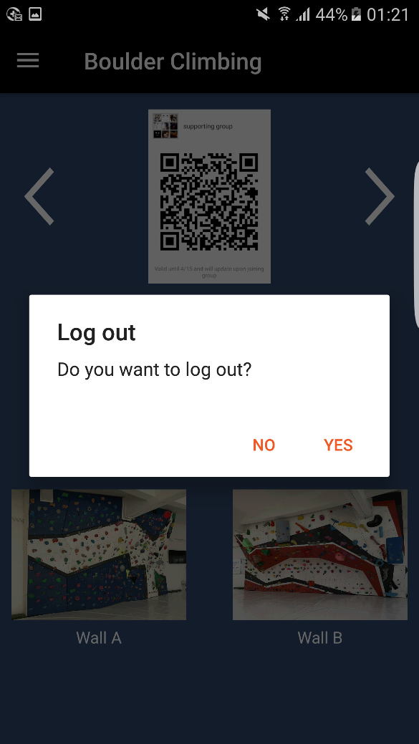

Figure 15: Log out

When you are logged in, you can log out by pressing on the “Log out” button. A window will pop up to prevent accidental triggering.

**Hamburger**

 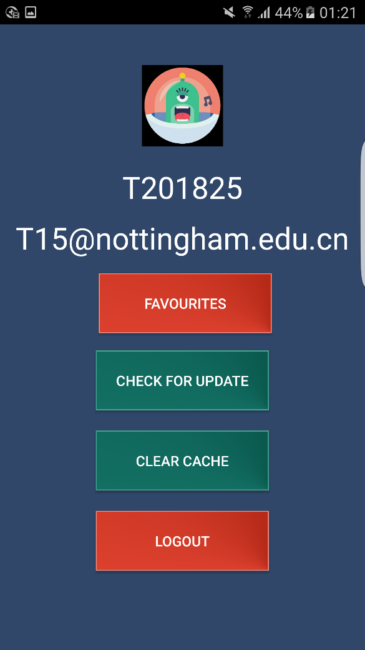

Figure 16: Profile

You can click your icon to jump to the profile page, where the personal information will be shown. In addition, you can go to favourite list, check the updated version of our application, clear the local cache or log out.

**Home Page**

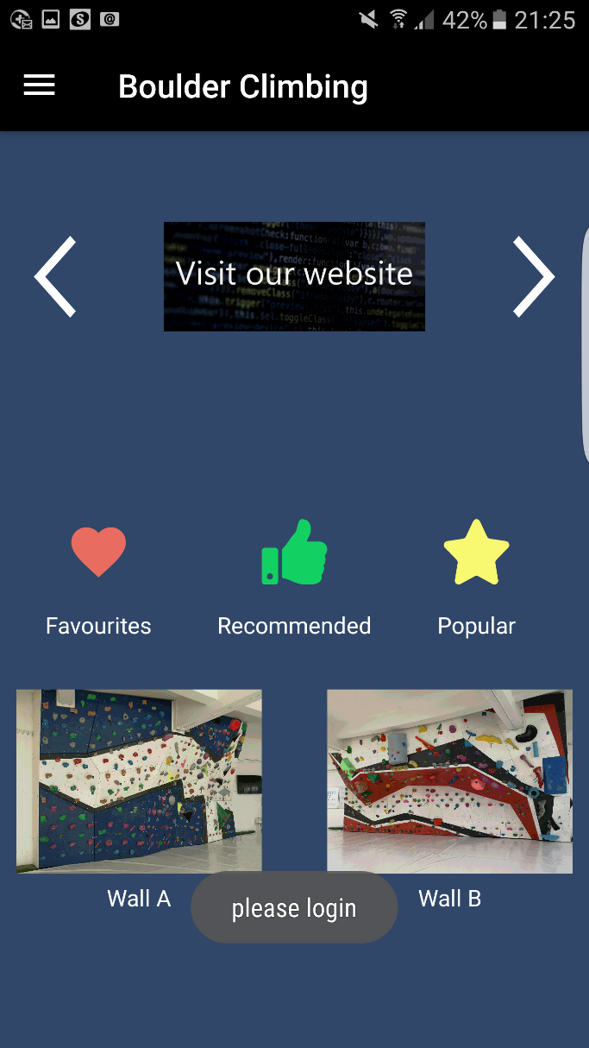

Figure 17: Favourites

Favourite list cannot be displayed if you are not logged in.

A prompt message will pop up.

**Home Page**

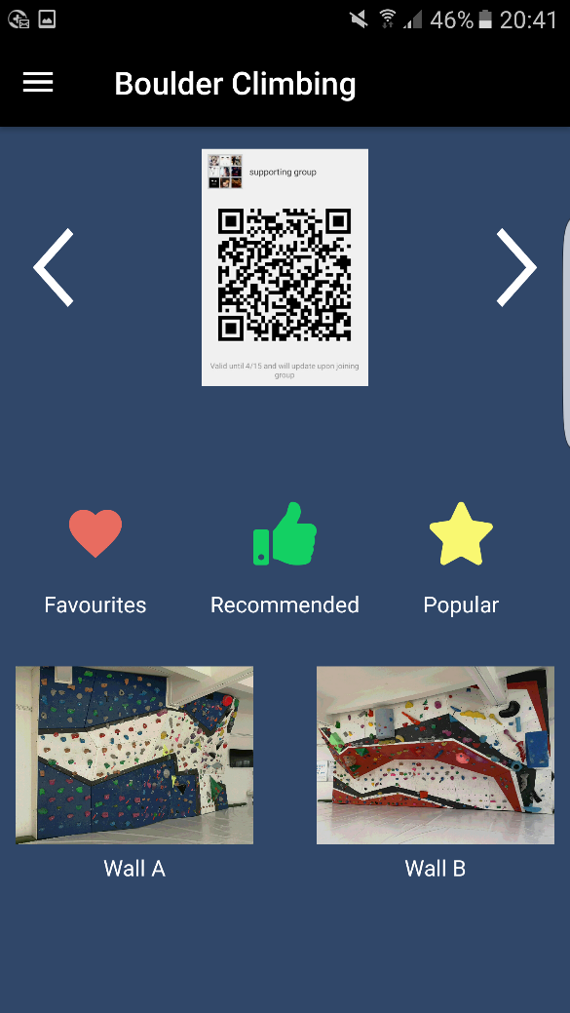

Figure 18: Favourite List

As long as you are logged in, “Favourite” button can be pressed to access the favourite routes.

**Favourite Page**

 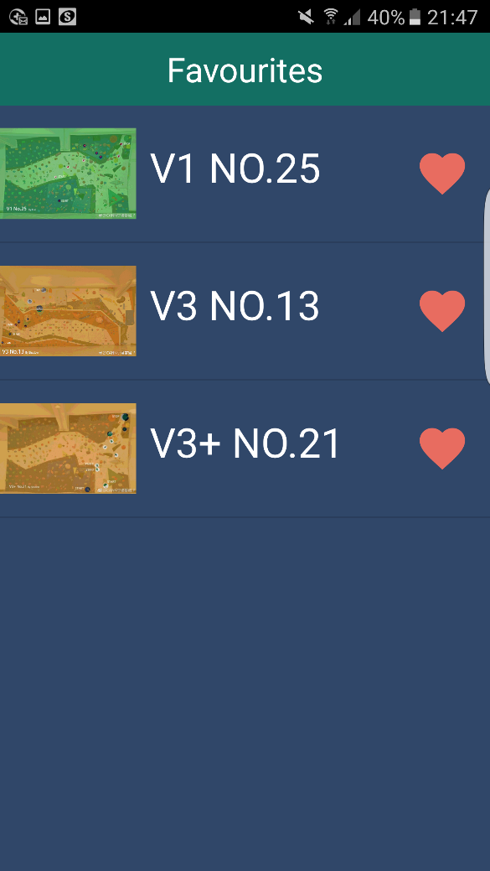

Figure 19: Remove Route

In the Favourites page, the routes are shown with their images and names. “Heart” buttons can be pressed to remove corresponding route from the Favourite list.

**Recommended Page**

 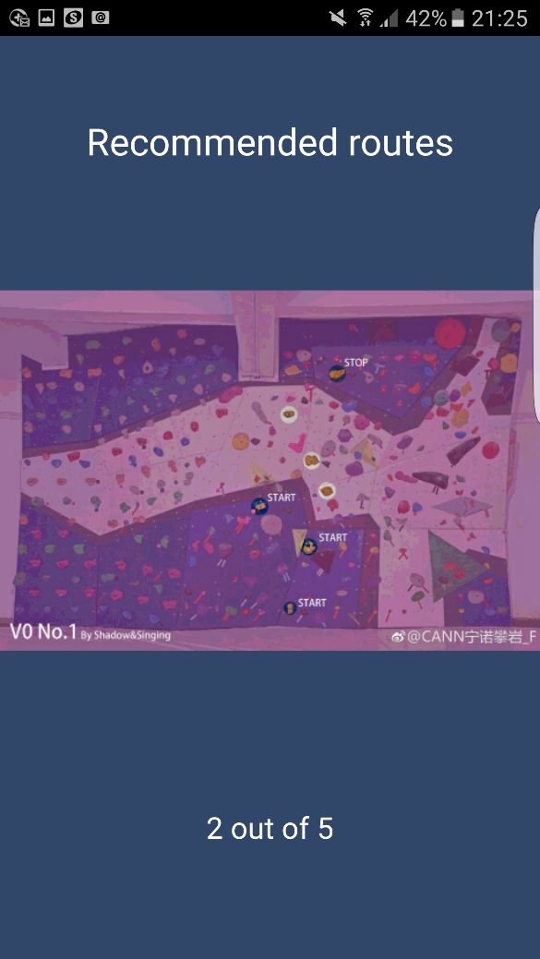

Figure 20: Recommended routes

You can go to the recommended routes page by pressing the “Recommended” button. It will display several routes recommended by our team, which are suitable for the new climbers. You can swap left or right to look through all routes.

**Popular Page**

 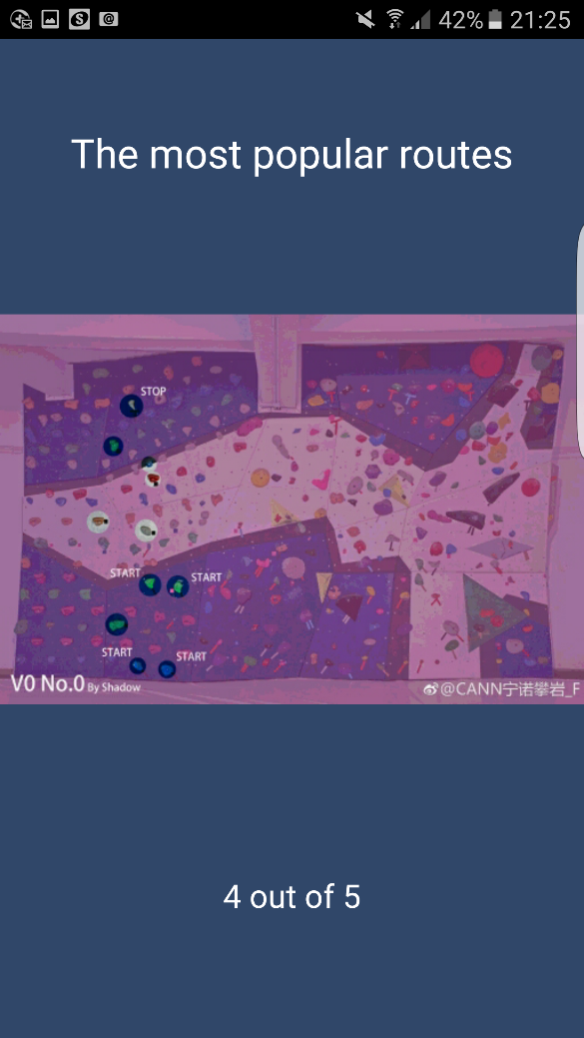

Figure 21: Popular Routes

You can go to the popular routes page by pressing on the “Popular” button. It will display the routes which are popular among the users according to number of climbers mark it as favourite. You can swap left or right to look through all routes.

**Routes Activity**

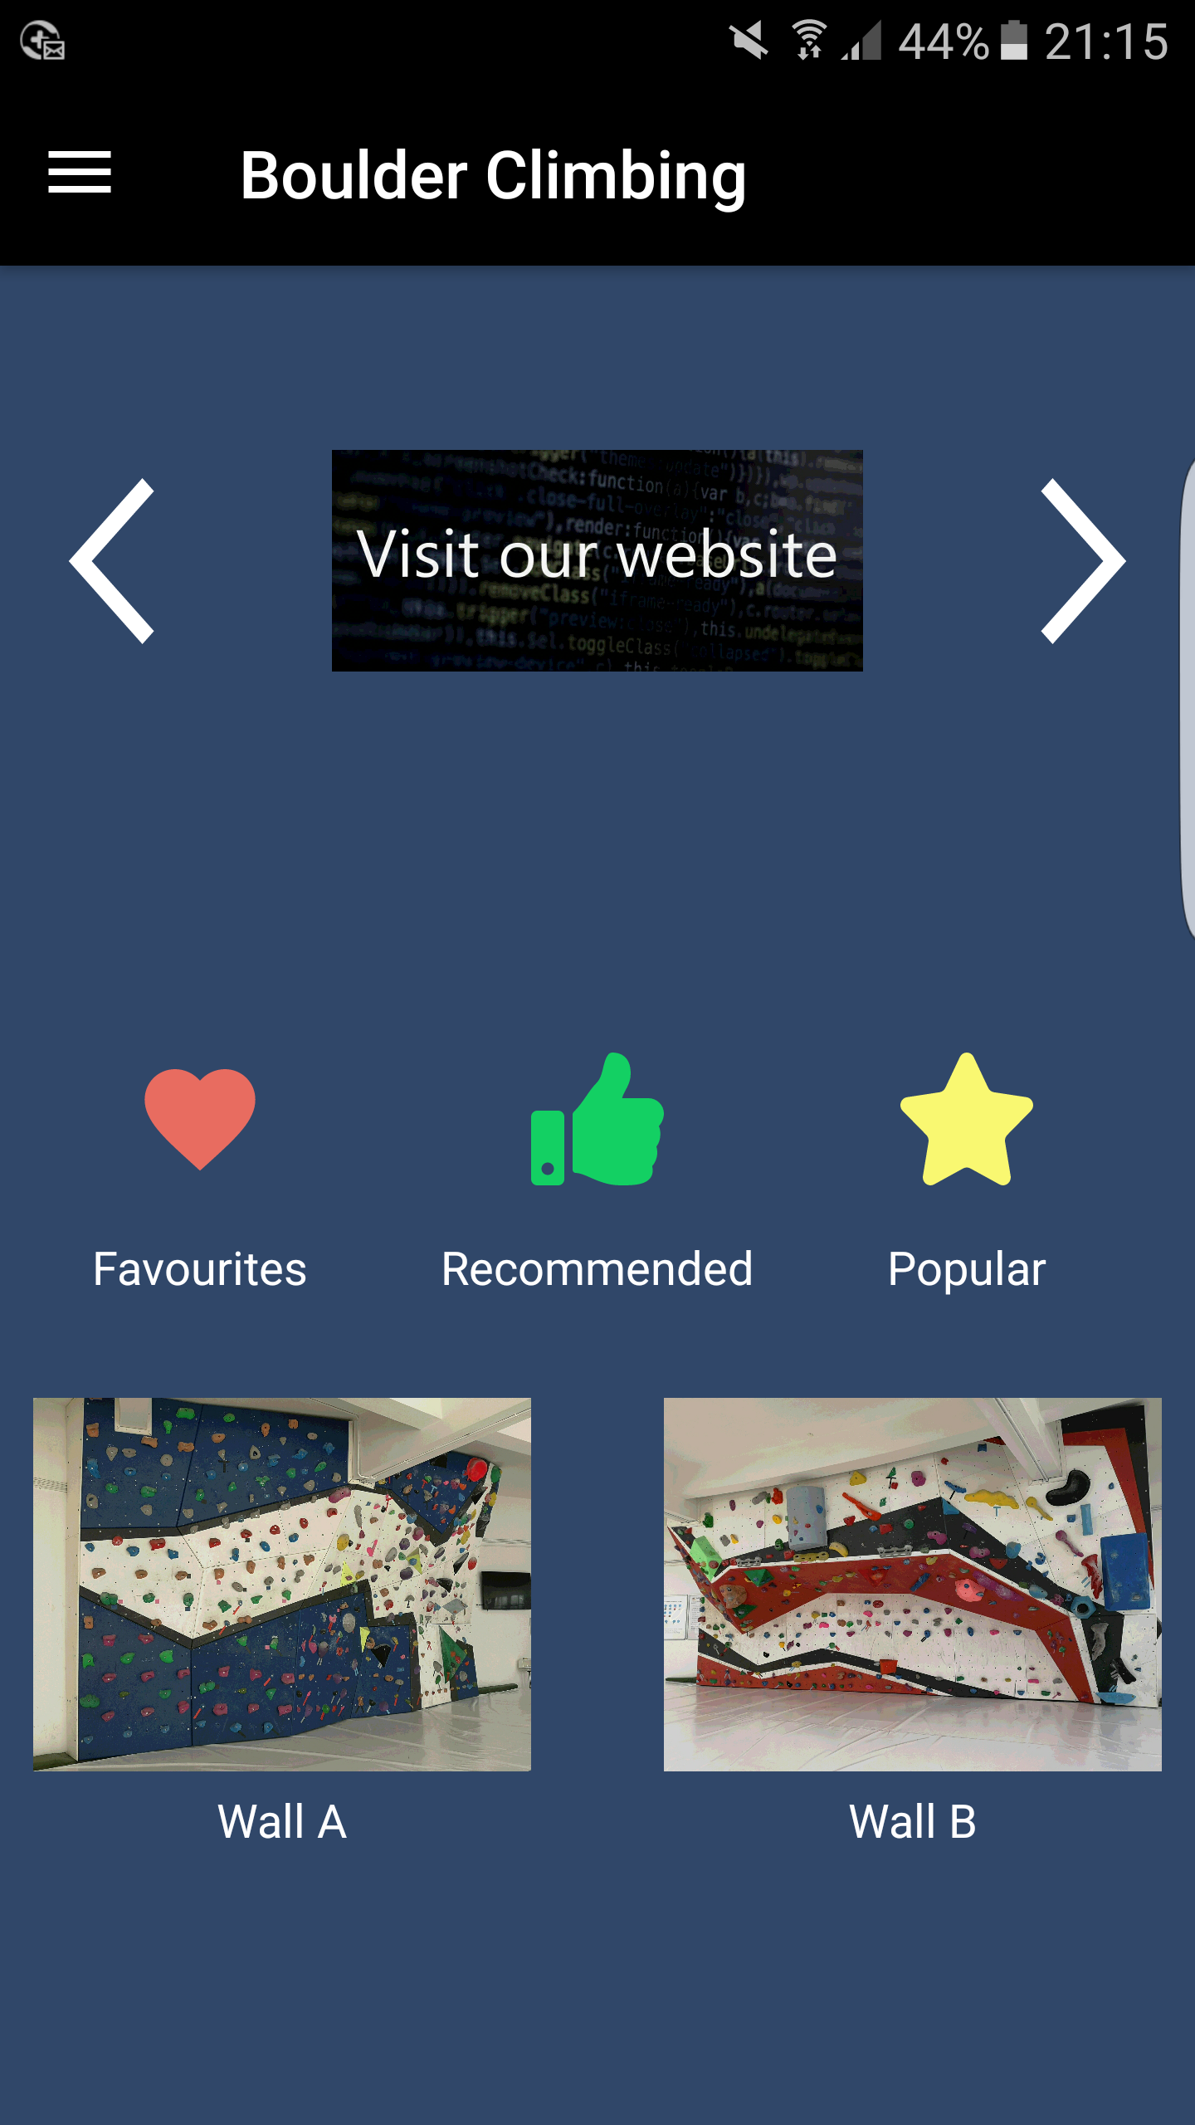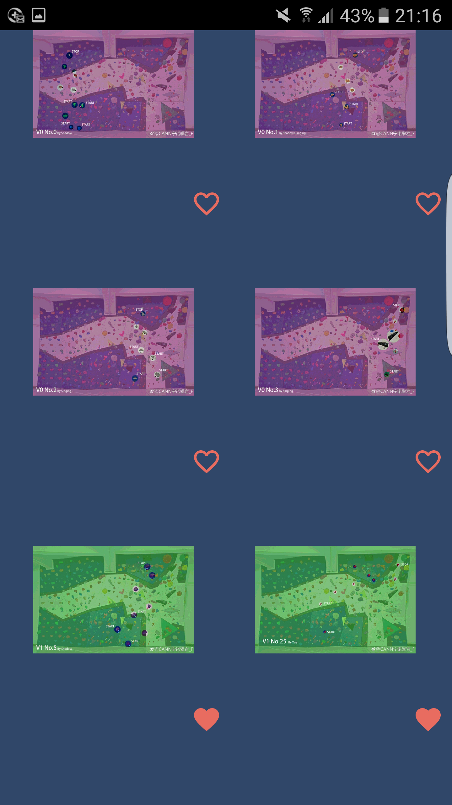

Figure 22: Walls - Routes

Press on an image of a wall to see all routes it has.

**Route Infomation Page**

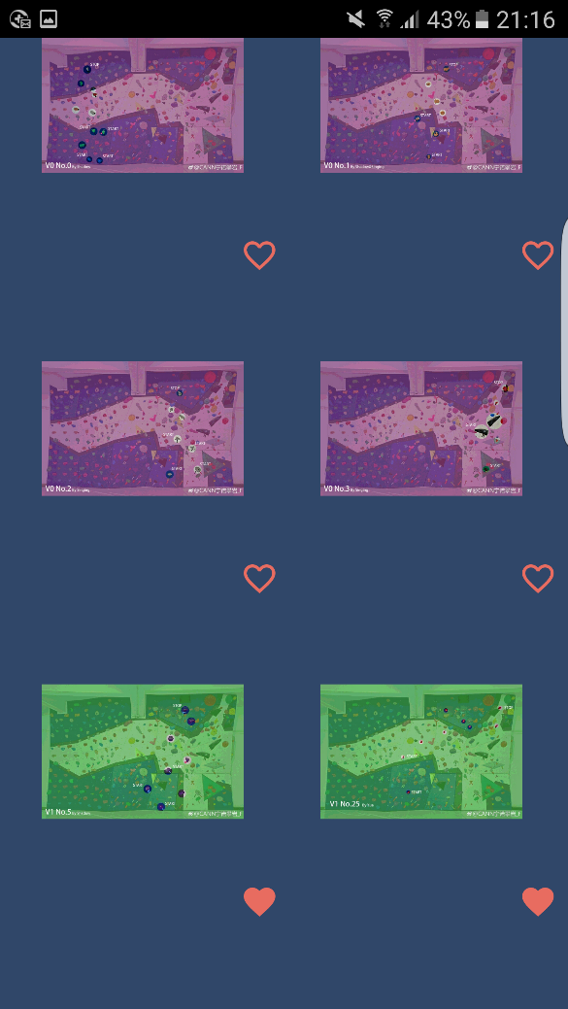 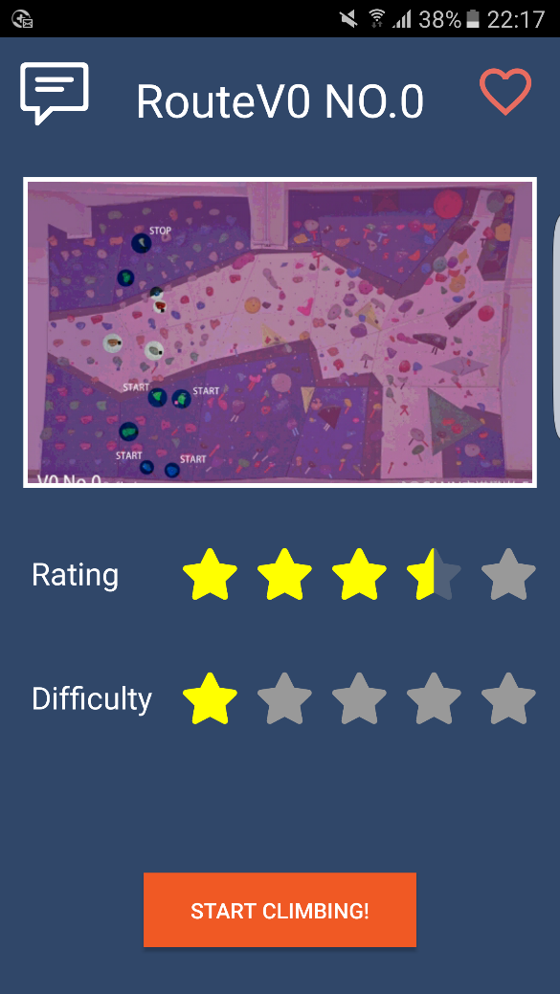**\**

Figure 23: Routes-Route Information Page

Pressing on a specific route will redirect you to that corresponding route’s information page. The details of that route, including name, picture, overall rating and diffciulty are shown. On the top, the “V” in the name represents the standard difficulty, the number respresents how hard it is.

**Route infomation Page**

 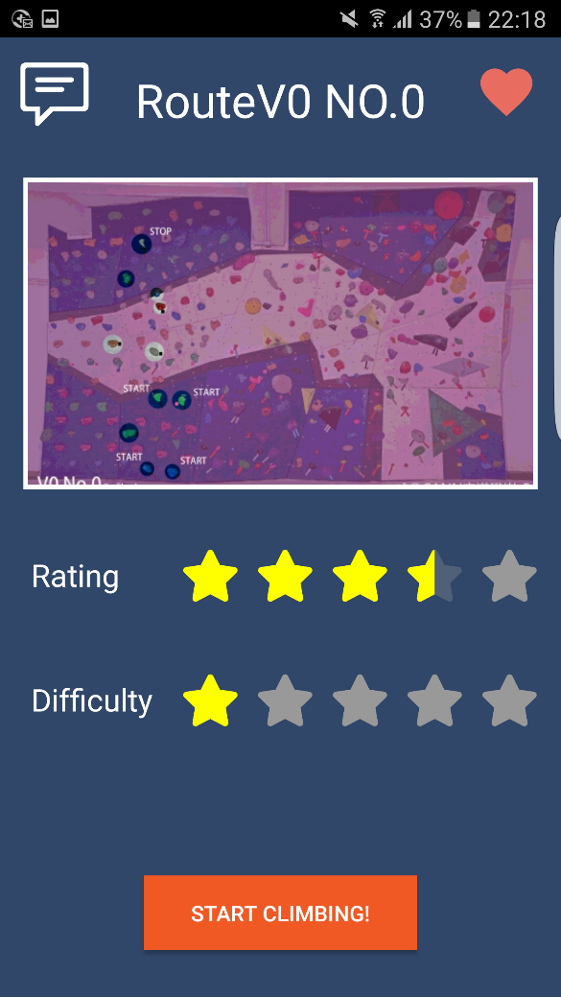

Figure 24: Favourite Button

The heart located in the top right corner shows if you have added this route into your favourite list. If it is not full, then it’s not your favourite, you can press on the heart to add the current route to your favorite list. And vice versa, if you press the heart when it is full, you will remove it from the list.

**Route infomation Page**

 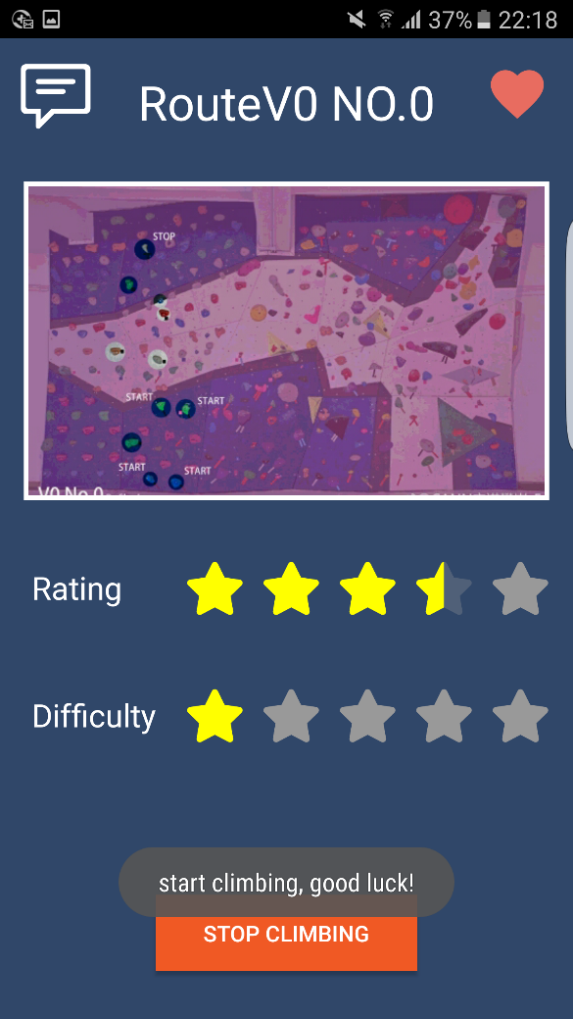

Figure 25: Start Climbing

When you want to start climbing a route, press the “start climbing” button to start a timer which records the climbing time.

**Route infomation Page**

 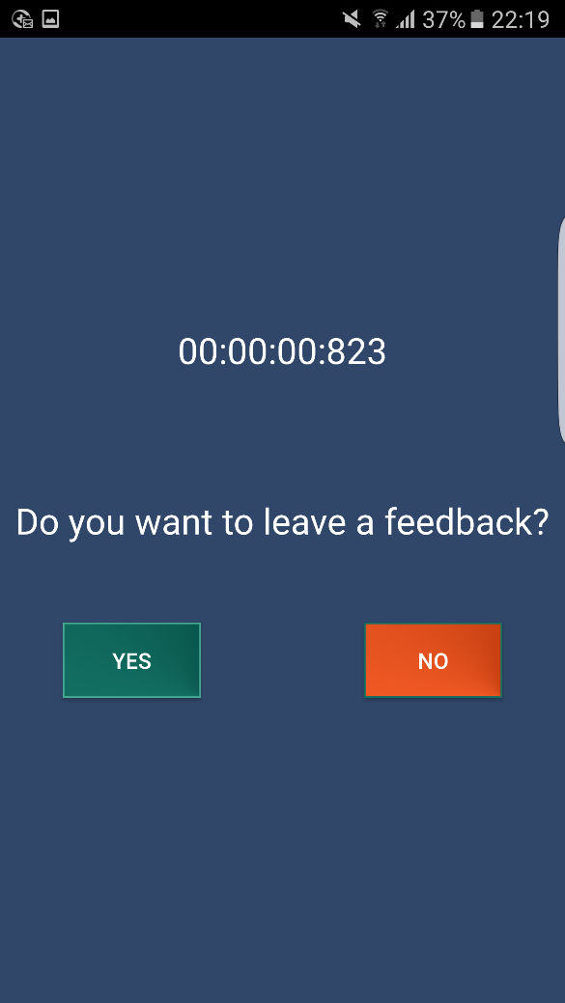

Figure 26: Stop Climbing

When you finish climbing, you can press “stop climbing” button to get your record. You can also leave your feedback if you want.

**Route infomation Page**

 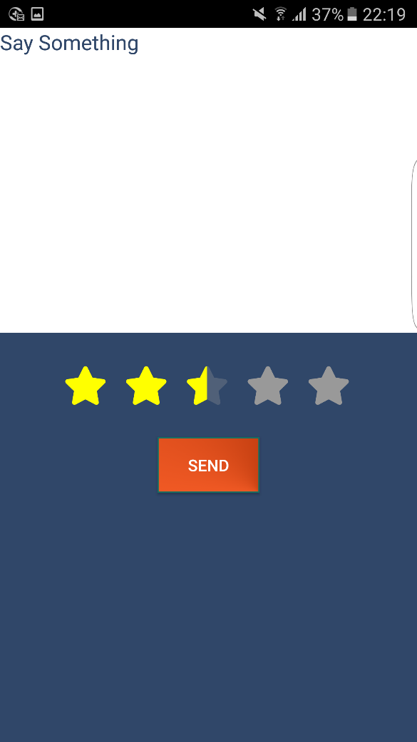

Figure 27: Leave a Comment

If you are logged in, you can press “YES” button to leave a comment and a rating on a route. Pressing on “NO” button, will return you to route information page

**Route infomation Page**

 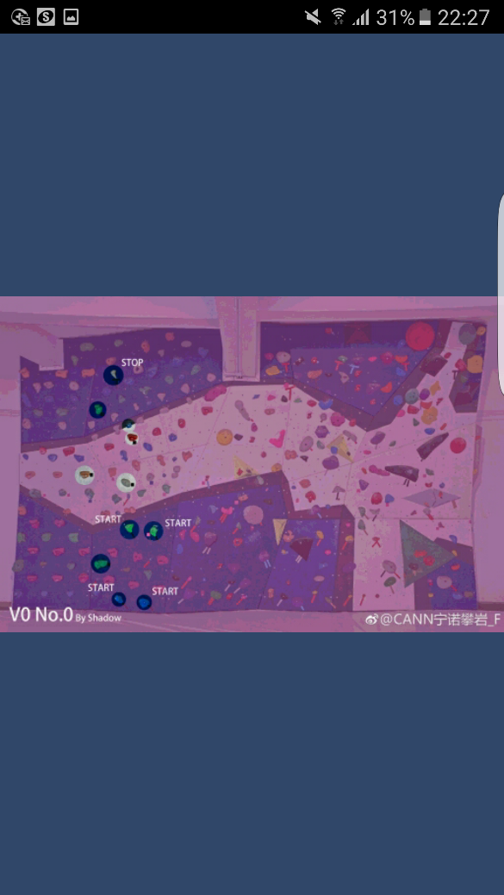

Figure 28: Larger Image

To view the zoomed in image of a route, you can press on the image. The larger picture will be shown in a new page.

**Route infomation Page**

 

Figure 29: Larger Image

You can also rotate your phone to view a larger route’s image which fits your phone’s size.

**Comment Page**

 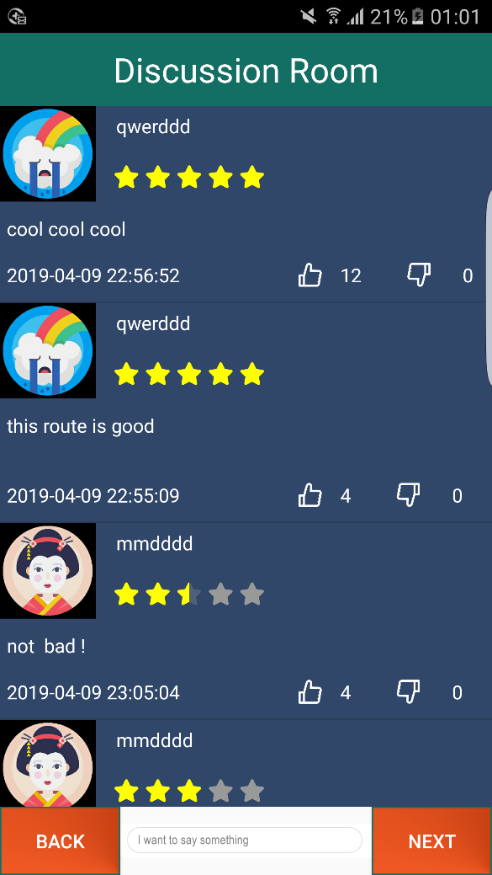

Figure 30: Route Information - Comment

The comment page can be accessed by pressing on the comment button located at the top left corner. Swiping on route information page can also redirect you to comments page. The avatar, user name, comment, time of comment, likes and dislikes of other users’ comments will be shown. Comments in the first page are ordered by likes and other pages by time.

**Comment Page**

 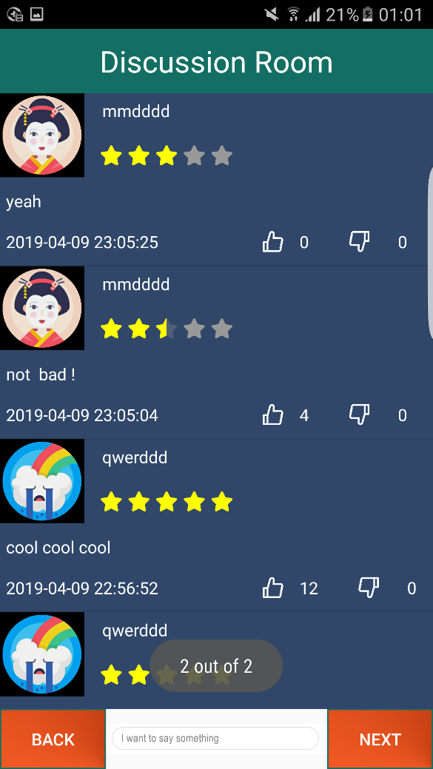

Figure 31: next and back page

You can go through the pages of comments by pressing “Next” and “Back” buttons. The page number will also be displayed.

**Feedback Page**

 

Figure 32: Leave feedback

You can leave a feedback and rate a route if you are logged in.